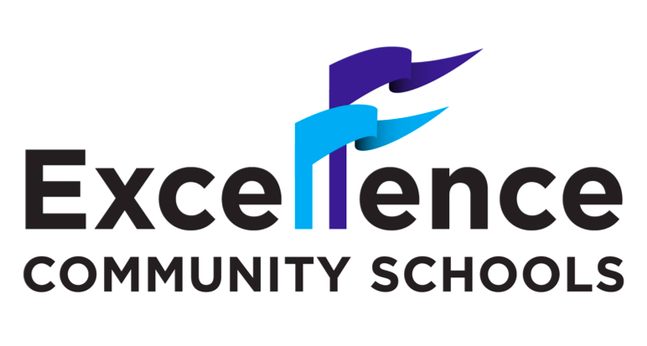

2019-2020 School Calendar
School Closings (all schools):
September 13 School Wide PD December 23-31 Winter Break
September 30 Rosh Hashanah January 1 New Year’s Day
October 1 Rosh Hashanah January 10 School Wide PD
October 9 School Wide PD January 20 MLK Day
October 14 Columbus Day February 7 School Wide PD
November 5 Election Day/PD February 17-21 Mid-winter Recess
November 11 Veteran’s Day April 6-10 Spring Recess
November 28-29 Thanksgiving Holiday May 25 Memorial Day
December 6 School Wide PD June 9 Clerical Day

Important Dates to Remember:

Elementary Schools Middle School
September 27 – Lunch forms due September 27 – Lunch forms due
November 27 – End of 1st marking period November 15 - End of 1st quarter
December 11-12 – Parent-Teacher Conferences 5-7pm Dec 4-5 – Parent-Teacher Conferences 5-7pm
March 6 – End of 2nd marking period February 3 – End of 2nd quarter
March 18-19 – PT Conferences 5-7pm (at-risk scholars) February 12-13 – PT Conferences (at-risk scholars)
June 19 – End of 3rd marking period April 24 – End of 3rd quarter
JUNE 26 – LAST DAY OF SCHOOL May 6-7 – PT Conferences 5-7pm (PID)
June 19 – End of 4th quarter
JUNE 26 – LAST DAY OF SCHOOL
Testing Dates:
March 25-27 NYS English Language Arts – Grades 3-8
April 21-23 NYS Mathematics – Grades 3-8
April 13 - May 15 NYSESLAT Speaking
May 4 - May 15 NYSESLAT Listening, Reading and Writing
May 18 - May 29 NYS Science Performance Test – Grades 4 and 8
June 1 NYS Science Written Test – Grades 4 and 8

Saturday Academy: Regents:
December 14 June 17 Living Environment @ 1:15p.m
January 11 & 25 June 18 – U.S. History & Gov’t @ 9:15a.m.
February 8 & 29 Algebra I @ 1:15p.m.
March 14 & 21 (Full day) June 22 – Spanish (written) @ 1:15p.m.
April 18 (Full day) June 24 – Geometry @ 9:15a.m.

*In addition to this calendar, each school will send out its own events calendar*
**The last day of school is June 26, 2020. HOWEVER, days may increase or decrease based on snow days. We are mandated to have at minimum 180 school days**
***BUSING WILL START ON WEDNESDAY, SEPTEMBER 12TH***

