My Pre-Kindergarten Academic Menu
Complete the daily Reading & Math Assignments using “IXL” through Clever
***For IXL Reading, please use the Kindergarten Language Arts lessons***
 | Monday 6/1 | Tuesday 6/2 | Wednesday 6/3 | Thursday 6/4 | Friday 6/5
Math  20 minutes | (E5) Fewer, more, and same  (K1) Name the shape | (E6) Are there enough?  (K2) Circles | (E7) Compare numbers (larger and largest)  (K3) Triangles | (E8) Compare numbers (smaller and smallest)  (K4) Squares | (F6) Above and below  (K5) Rectangles
Reading  40 minutes | (F2) Choose the picture that rhymes with the word  (U3) What am I?  *Use the Kindergarten Language Arts lessons* | (F3) Which word does not rhyme?  (W1) Compare pictures using adjectives  *Use the Kindergarten Language Arts lessons* | (G2) Identify the first, second and last sound in a word  (X1) Inside and outside, above and below, next to and beside  *Use the Kindergarten Language Arts lessons* | (H1) Which two words start with the same sound?  (X2) Choose the best location word to match the picture  *Use the Kindergarten Language Arts lessons* | (H2) Find all the words that start with a given sound  (Y1) Who, what, when, where or why?  *Use the Kindergarten Language Arts lessons*
Choose a way to read for 20 minutes every day
Read and listen to classical music Read with sunglasses on Read a realistic fiction book
This Week’s Theme is…  Robots  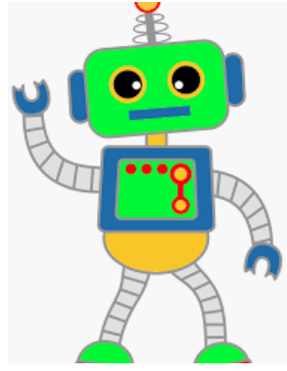 | Essential Question: How can you make a robot?  This Week’s Adventure: Build Your Own Robot  Directions: Did you know robots are everywhere? They can do many important jobs to help people. For example, robots help build things, they help explore places like space and they help solve problems. Robots come in different shapes and sizes; they can be big, small, short or tall. This week, your job is to build a robot using different shapes, colors and materials. Robots can look like people, animals, a car or something different. So what will your robot look like?  Guiding Questions:  - What materials will you use to construct your robot?  - Will your robot be made of 2-D or 3-D shapes?  - How can you make your robot move?  - What job does your robot do?  Continue the Adventure with…  Watch: Robots for Kids  Read: Robots, Robots Everywhere!  Learn: Learn all about Real-Life Robots  Dance: Can you Dance Like a Robot?  Play: Try to play robot with a family member. Remember to talk and walk just like robots do!

